**What is CI?**

Stands for Continuous Implementation. CI is enabling the automation of the software build process thereby providing anytime current builds for testing, demonstration or release purposes. Through its approach, CI allows teams to spend less time debugging and more time developing new features. Moreover, CI pushes developers to create modular and less complex code.

**What is CD?**

Stands for Continuous Delivery. Continuous delivery is an ongoing DevOps practice of building, testing, and delivering improvements to software code and user environments with the help of automated tools. The key outcome of the continuous delivery (CD) paradigm is code that is **always** in a deployable state.

-Benefits of CI/CD?

-Tools

**Tools listed below are some of the top CD Tools:**

1. **Top Overall** – Buddy
2. **Software Containers** – JBoss, Tomcat, HUDSON
3. **Build Tools** – Ant, Rake, Maven
4. **Code Review & Insight tools** – Crucible, Fisheye
5. **Code Insight** – Fisheye
6. **Continuous Integration** – Jenkins, Bamboo
7. **Cloud IaaS &PaaS tools** – AWS, Windows Azure, Google App Engine and more
8. **Database & DB management tool** – Oracle, MySQL, Liquibase,SQL Server
9. **Infrastructure Automation** – Puppet, Chef [Now Terraform is the trend]
10. **Dependency Management** – Nexus
11. **Deployment Automation** – Java Secure Channel, Fabric
12. **Integrated Development Environment (IDE)** – Eclipse, Visual Studio
13. **Issue Tracking** – JIRA, Greenhopper
14. **Provisioning tools** – Eucalyptus
15. **Monitoring** – CloudKick, Zabbix, Nagios
16. **Testing** – AntUnit, Cucumber,  JMeter, SoapUI, Selenium
17. **Version-Control System** – GIT, SVN/Subversion, Perforce

**Tools listed below are some of the top CI Tools:**

1. Jenkins
2. TeamCity
3. Bamboo
4. Buddy
5. GitLab CI
6. CircleCI
7. TravisCI

***Self-learning content***

<https://www.udemy.com/course/ci-cd-devops/> [This is suitable for the beginner] - DevOps

<https://www.udemy.com/course/devops-ci-cd-with-jenkins/> [This is suitable for beginners] - Jenkins

<https://www.udemy.com/course/jboss-eap-basics-administrationconfiguration-development/> [This is suitable for beginners] - JBoss

<https://www.udemy.com/course/aws-certified-solutions-architect-associate-saa-c02/learn/> [This is suitable for beginners] – AWS

<https://www.redhat.com/en/services/training/do407-automation-ansible-i> [This is for configuration management] - Ansible

<https://www.redhat.com/en/services/training/ex405-red-hat-certified-specialist-in-configuration-management-exam> [This is for configuration management] – Puppet

<https://www.udemy.com/course/learn-devops-infrastructure-automation-with-terraform/learn/> - [This is Infrastructure Automation Tool] – Terraform

<https://www.udemy.com/course-dashboard-redirect/?course_id=2301254> [This is for Container Orchestration] – Kubernetes

<https://www.udemy.com/course-dashboard-redirect/?course_id=1035000> [This is for Containerization] – Docker

Assignments for tools

1. AWS/ GCP/ Azure or Oracle Cloud Platform – Create a VPC in any region using the free tier account [Private Subnet, Public Subnet, Bastion Host, NACL, NAT Gateway etc.]
2. Create a basic Linux server on Could platform and setup install the MariaDB service on the host using the programing language or shell scripting knowledge. [You can use Perl, Bash, Python]
3. Install the Nagios core or Zabbix open source monitoring tool on Linux EC2 instance and monitor the MariaDB service running host. You have to monitor the CPU Utilization, Memory Utilization likewise.
4. Install Puppet on Linux EC2 instance [Master node and Client node] setup the webserver on client node using the configurations on Master node. [You can use Apache or Nginx]
5. Install Vagrant/ Terraform on your own pc and create a basic script for “Create, up and run the CentOS7 server” on AWS infrastructure.
6. Install the Nginx on EC2 instance using the knowledge of “GIT Cloning” skills. If you know containers, you can create a basic Nginx container on your EC2 instance.

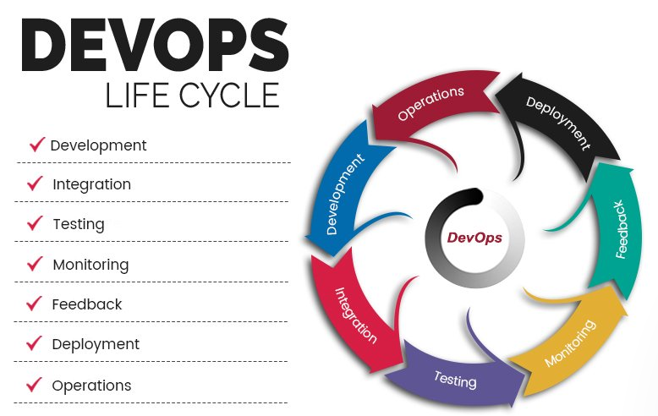

<https://raygun.com/blog/best-devops-tools/> - Most popular DevOps tools.

In this document I’m didn’t mention the Servers, Virtualization, Containers and Server Less. In IaaS section all things are included.

Also, Student should have the basic Networking and Security concepts. Otherwise in the creating the infrastructure section, they are on trouble.

